**Project Title:** University Admit Eligibility Predictor **Project Design Phase-I** - **Solution Fit Template Team ID:** PNT2022TMID10456

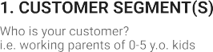

Students who have graduated from ug or 12th

Based on the rank of the student available colleges will be shown and not their desired ones.

In those days rankings will be casted in mass gathering where all students will be present, they should keen enough to notice their ranking to get into respective colleges but now we can easily complete the process via online.

.

Eligible candidates will be allocated to top

Ranking Universities based on their marks. Saves

lot of effort and time for students.

Sometimes students are unable to reach the Many students addressed their problems

place on time which results in missing of the to media which results in developing of

colleges they wish for. software to predict the colleges based on the

students rank.

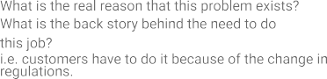

|  |  |  |  |  |
| --- | --- | --- | --- | --- |
|  | **3. TRIGGERS TR**  Tiredness and expenses in travel during admission in colleges. | **10. YOUR SOLUTION SL**  Based on the student’s ranking list respective colleges will be displayed. The student’s can check their eligibility for each college based on the prediction graph given. | 1. **CHANNELS of BEHAVIOUR CH**    1. **ONLINE**   Students can check their college infrastructure, courses available.   * 1. **OFFLINE**   Students can pay their fees in their college and get admitted. |  |
| **4. EMOTIONS: BEFORE / AFTER EM** They will be tensed beforehand because the rank of the student is unknown and after knowing through ranking system they can predict the colleges to which they belong. |